**Part I**

**Choose the right answer!**

1. I would cook soup if you **brought/had brought** some vegetables this morning.
2. If she **doesn’t hurry/doesn’t hurries,** she will be late.
3. If it **rains/rain**, the grass grows.
4. My Ideal holiday would **be/have been** a week in my house without do nothing.
5. I would **have been/been** a famous writer if I had **send/sent** my work to the publisher.
6. If I **had had/have** good luck, I would have won the first prize.
7. If I **got/get** the earlier bus, I **could/can** come home at 5 o'clock.
8. If you had told me the truth, I **would have helped/help** you.
9. If Susan **takes/take** her driving lessons regularly, she will pass her driving test.
10. I'll give you a piece if mother **makes/make** apple pie.

**Part II**

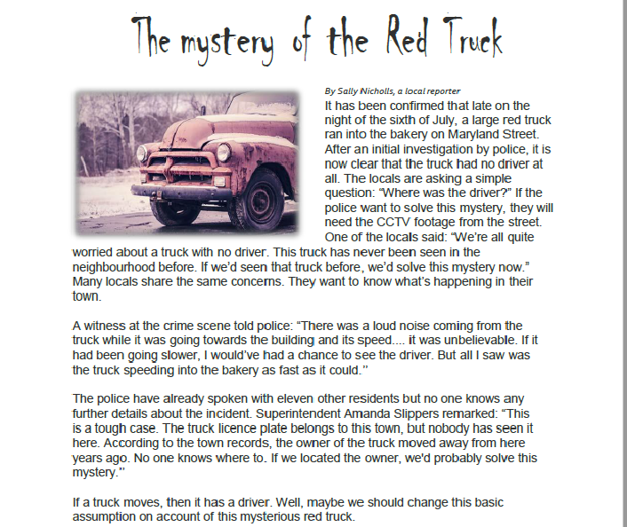**Read the text carefully and identify the "If conditional" expression from the text.**

**1. How many “If Conditional” expressions did you find? Please write them down!**

|  |
| --- |
| 1. |
| 2. |
| 3. |
| 4. |
| 5. |
| 6. |

**2. Decide if the statements are *true* or *false* according to the text.**

1. The locals knew that the red truck had an old driver. _____
2. The police have investigated all the people in the town. _____
3. The CCTV footage of the street will help the police. _____
4. The locals haven’t seen the truck in the town before. ______
5. The truck ran into the building very slowly. _____